**Screenshots of the assignment**

**1.Initial Page:**

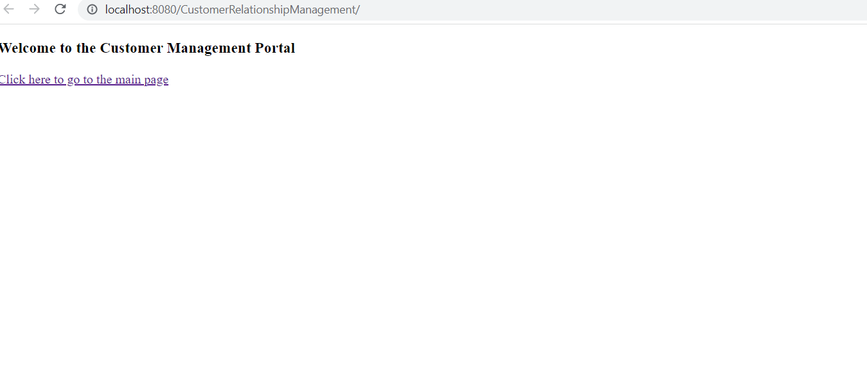

**2. Main Page view:**

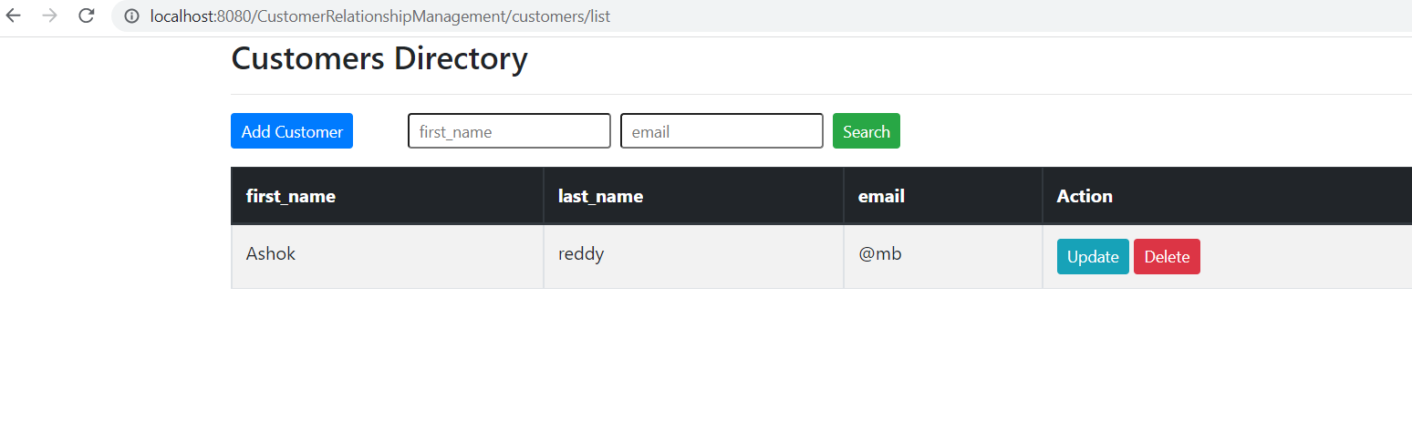

**3.Add customer form**

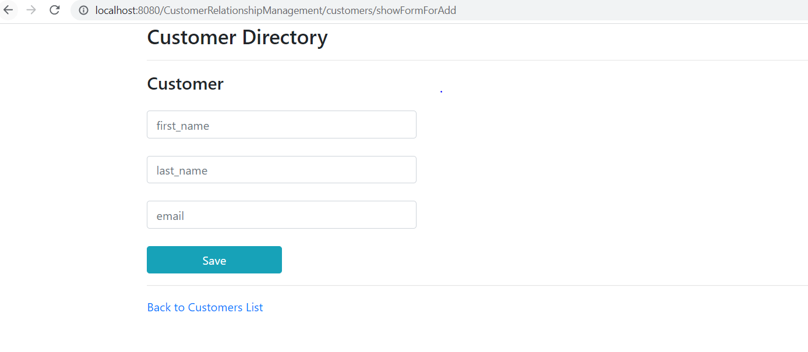

**4.Update form**

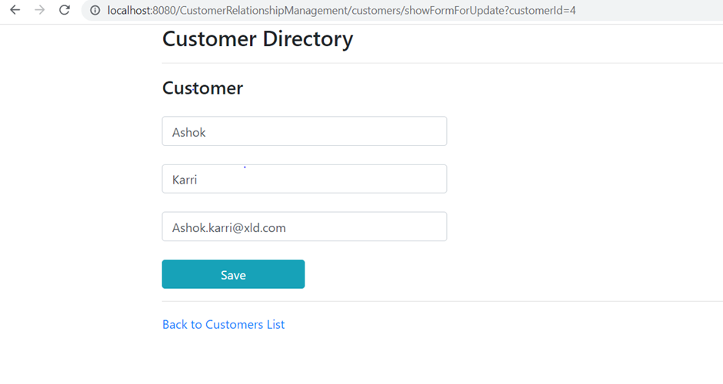

**5. Delete**

**5.Delete**

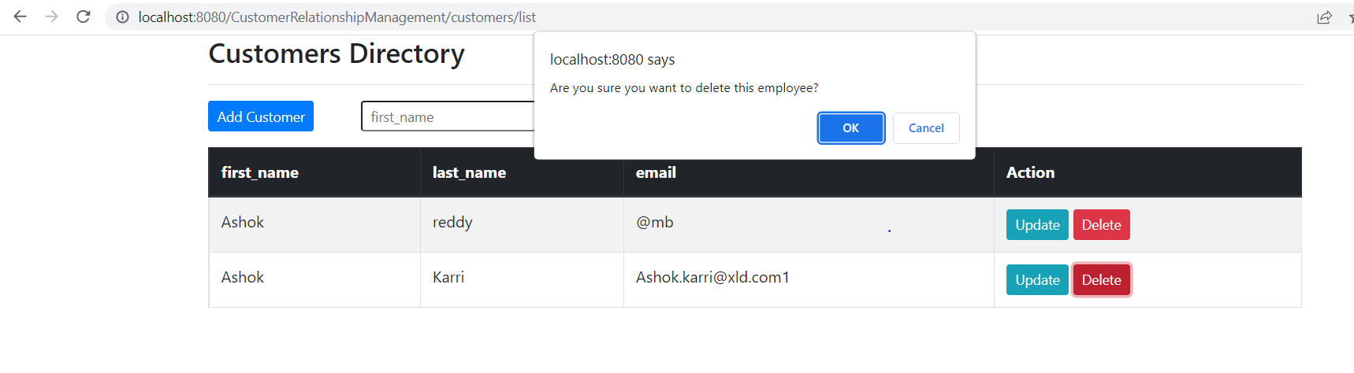

**6.URL for the screen recording of the Assigment:**

**https://drive.google.com/file/d/1qrynTz_xx9FO5BvbWkkh9VK0AUbAD418/view?usp=sharing**